MAT 171 Pre-Calculus Algebra Lab Name: ______________________

Recall:
Distance Formula | Midpoint Formula | Equation of a Circle in Standard Form
- Consider a circle with endpoints of a diameter of (7, 13) and (-3, -11).
  - Write the equation of a circle in standard form.

  - Identify the Center

  - Identify the Radius

  - Graph. (Hint you may have to scale your axis. It is wise to scale the x- and y-axis by the same factor.)
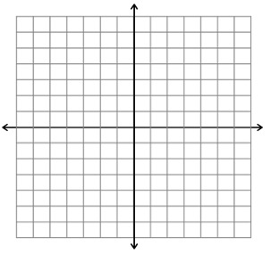
  - What would be the equation of this circle in general form?

- Consider the circle
  - What is the center and radius?

  - Sketch the curve
Calculus Preview:
  - What does it mean to be tangent to a circle? (You may need to look it up on the internet)

  - Write the equation of the tangent line to the circle above that touches the circle at (3,-4) and has a slope of ¾.

  - Sketch the tangent line on the graph in 8b.

  - What does it mean to be a secant line to a circle? (You may need to look it up on the internet)

  - Write the equation of the secant line to the circle that passes through (3,-4) and (0, 5).

  - Sketch the secant line on the graph in 8b.

- The points (-9,4), (-2, 5), (-8,-3) and (-1, -2) are the vertices of an inscribed square. Find the equation of the circle in standard form. Then find the area of region enclosed by the square and outside of the circle. (Hint you will need to use the formula for the area of a circle. If you don’t know it, you will need to look it up.)

- Find the equation of a circle in standard form that has a center at (-5, 8) with a circumference of 10π units. (Hint you will need to use the formula for a circumference of a circle. If you don’t know it, you will need to look it up.)

