# Graphical Analysis of Exponential Functions

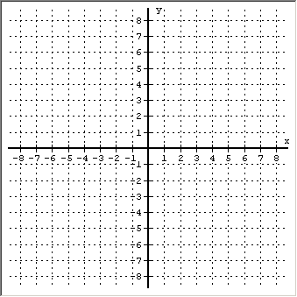Name:

### Consider the equation: *y*   3*x*

1. Function? yes/no
2. One-to-One Function? yes/no
3. State any Symmetry:
4. Domain using interval notation:
5. Range using interval notation:
6. *x*-intercept(s):
7. *y*-intercept:
8. Are there any Asymptotes? If yes, then give the equation(s)
9. Where is *f* (*x*)   0 ? State the x-values using interval notation
10. Where is *f* (*x*)   0 ? State the x-values using interval notation
11. Where is *f* (*x*)   0 ? List the x-value(s)
12. Where is *f* (*x*) increasing? State the x-values using interval notation
13. Where is *f* (*x*) decreasing? State the x-values using interval notation
14. Where is *f* (*x*) concave up? State the x-values using interval notation
15. Where is *f* (*x*) concave down? State the x-values using interval notation

### Consider the equation:

1. Function? yes/no
2. One-to-One Function? yes/no
3. State any Symmetry:
4. Domain using interval notation:
5. Range using interval notation:
6. *x*-intercept(s):
7. *y*-intercept:
8. Are there any Asymptotes? If yes, then give the equation(s)
9. Where is *f* (*x*)   0 ? State the x-values using interval notation
10. Where is *f* (*x*)   0 ? State the x-values using interval notation
11. Where is *f* (*x*)   0 ? List the x-value(s)
12. Where is *f* (*x*) increasing? State the x-values using interval notation
13. Where is *f* (*x*) decreasing? State the x-values using interval notation
14. Where is *f* (*x*) concave up? State the x-values using interval notation
15. Where is *f* (*x*) concave down? State the x-values using interval notation

 **3. Graph function  . Label two points.**

1. Domain:
2. Range:
3. Describe the transformation:
4. Equation of horizontal Asymptote

**4. Graph function  . Label two points.**

1. Domain:
2. Range:
3. Describe the transformation:
4. Equation of horizontal Asymptote

**5. Graph function  . Label two points.**

1. Domain:
2. Range:
3. Describe the transformation:
4. Equation of horizontal Asymptote

**6. Graph function  . Label two points.**

1. Domain:
2. Range:
3. Describe the transformation:
4. Equation of horizontal Asymptote

**7. Graph function  . Label two points.**

1. Domain:
2. Range:
3. Describe the transformation:
4. Equation of horizontal Asymptote

**8. Graph function  . Label two points.**

1. Domain:
2. Range:
3. Describe the transformation:
4. Equation of horizontal Asymptote

**9. Graph function  . Label two points.**

1. Domain:
2. Range:
3. Describe the transformation:
4. Equation of horizontal Asymptote

# Functions and Inverses

**10. Graph function  and  . Label two points.**

1. Domain ****:
2. Range ****:
3. Equation of Asymptote of 
4. Domain ****:
5. Range ****:
6. Equation of Asymptote of 

**Drug Medication**

11. The formula  can be used to find the number of milligrams (mg) ***D*** of a certain drug that is in a patient’s bloodstream after ***t*** hours, assuming that ***D0*** mg of the drug is administered initially (*t* = 0). Assume 5 mg of the drug is administered initially.

a) What is the equation?

b) Approximately how many mg of the drug will be present in the bloodstream after … (Round to 1 decimal place)

|  |  |
| --- | --- |
| Time (t) | Number of mg left in bloodstream D(t) |
| 0 hours |  |
| 1 hours |  |
| 3 hours |  |
| 6 hours |  |
| 10 hours |  |

c) Use this data and sketch the graph of the exponential function below. Label the axes.



d) When the number of mg of the drug in the patient’s bloodstream reaches 2 mg, the drug needs to be administered again. Approximately how long until another injection needs to be administered?