# Graphical Analysis of Logarithmic Functions

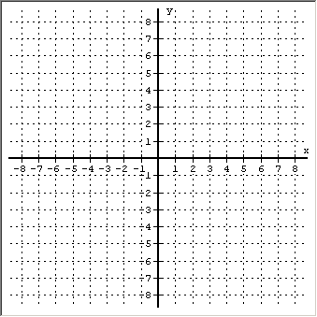Name:

### Consider the equation: Graph: *y* log3x

1. Function? yes/no
2. One-to-One Function? yes/no
3. State any Symmetry:
4. Domain using interval notation:
5. Range using interval notation:
6. *x*-intercept(s):
7. *y*-intercept:
8. Are there any Asymptotes? If yes, then give the equation(s)
9. Where is *f* (*x*)   0 ? State the x-values using interval notation
10. Where is *f* (*x*)   0 ? State the x-values using interval notation
11. Where is *f* (*x*)   0 ? List the x-value(s)
12. Where is *f* (*x*) increasing? State the x-values using interval notation
13. Where is *f* (*x*) decreasing? State the x-values using interval notation
14. Where is *f* (*x*) concave up? State the x-values using interval notation
15. Where is *f* (*x*) concave down? State the x-values using interval notation

### Consider the equation: Graph

1. Function? yes/no
2. One-to-One Function? yes/no
3. State any Symmetry:
4. Domain using interval notation:
5. Range using interval notation:
6. *x*-intercept(s):
7. *y*-intercept:
8. Are there any Asymptotes? If yes, then give the equation(s)
9. Where is *f* (*x*)   0 ? State the x-values using interval notation
10. Where is *f* (*x*)   0 ? State the x-values using interval notation
11. Where is *f* (*x*)   0 ? List the x-value(s)
12. Where is *f* (*x*) increasing? State the x-values using interval notation
13. Where is *f* (*x*) decreasing? State the x-values using interval notation
14. Where is *f* (*x*) concave up? State the x-values using interval notation
15. Where is *f* (*x*) concave down? State the x-values using interval notation

 **3. Graph function  . Label two points.**

1. Domain:
2. Range:
3. Describe the transformation:
4. Equation of Asymptote

**4. Graph function  . Label two points.**

1. Domain:
2. Range:
3. Describe the transformation:
4. Equation of Asymptote

**5. Graph function  . Label two points.**

1. Domain:
2. Range:
3. Describe the transformation:
4. Equation of Asymptote

**6. Graph function  . Label two points.**

1. Domain:
2. Range:
3. Describe the transformation:
4. Equation of Asymptote

**7. Graph function  . Label two points.**

1. Domain:
2. Range:
3. Describe the transformation:
4. Equation of Asymptote

**8. Graph function  . Label two points.**

1. Domain:
2. Range:
3. Describe the transformation:
4. Equation of Asymptote

**9. Graph function  . Label two points.**

1. Domain:
2. Range:
3. Describe the transformation:
4. Equation of Asymptote