**Exploring Sequences & Series on Excel**

Make an Excel spreadsheet with the following columns:

Column A = Term Number

Column B = Term Value

Column C = Cumulative Sum of Terms (i.e. sum of all terms from beginning up to this point)

Start the term count at  (one extra term before the usual start at 1)

End the term count at 

Use the Sequence Term Value rule 

If you are unsure of how to set up the spreadsheet formulas, the screen shots below show the formulas and calculated values for the first few rows.

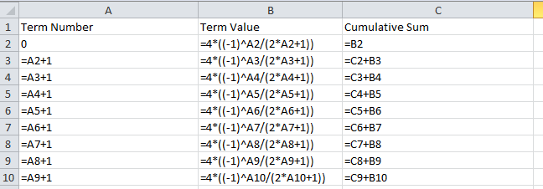

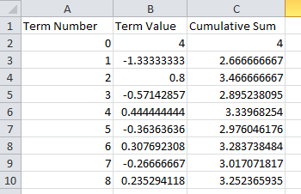

Questions:

Look at the column of cumulative sum values. Are they growing without bound or are they bounded?

If they are bounded, do you recognize the limit that the cumulative sum values seem to be approaching?

If not, continue (copy the formulas) until . Now do you recognize the limit value?